HOW TO SETUP JENKINS JOBS FOR TESTING AND DEPLOYING WEBPAGES ??

* Assumptions : jenkins and docker is installed and jenkins have superuser power .

1. Create workspace and initialise git .
2. Also create 2 branches as shown below:

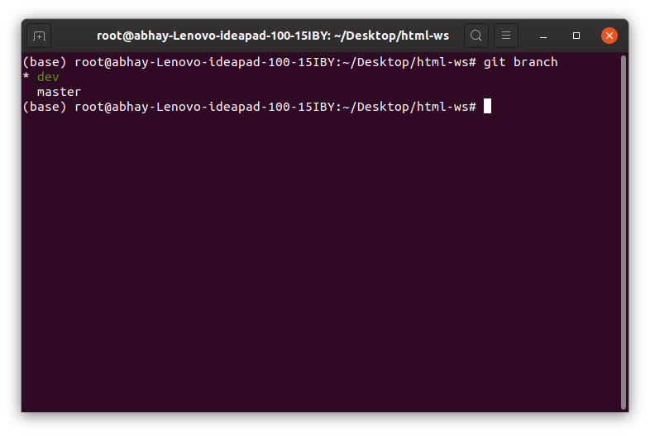

1. Create repo on github for push the webpages.

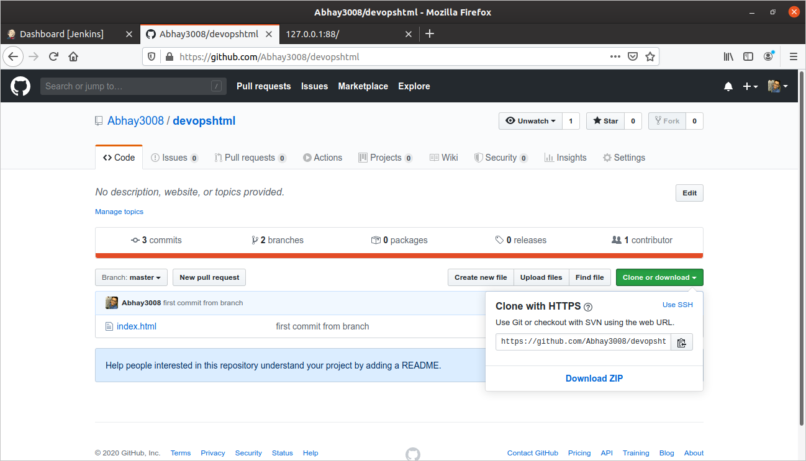

**- CREATING JOB1**

1. Create master-job and provide github repo link in SCM section

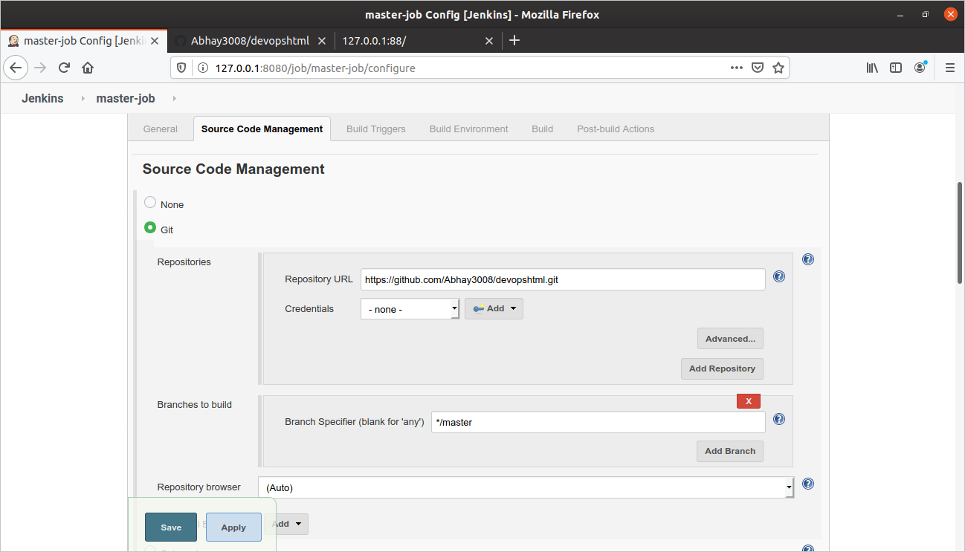

1. Set build triggers to every minute.

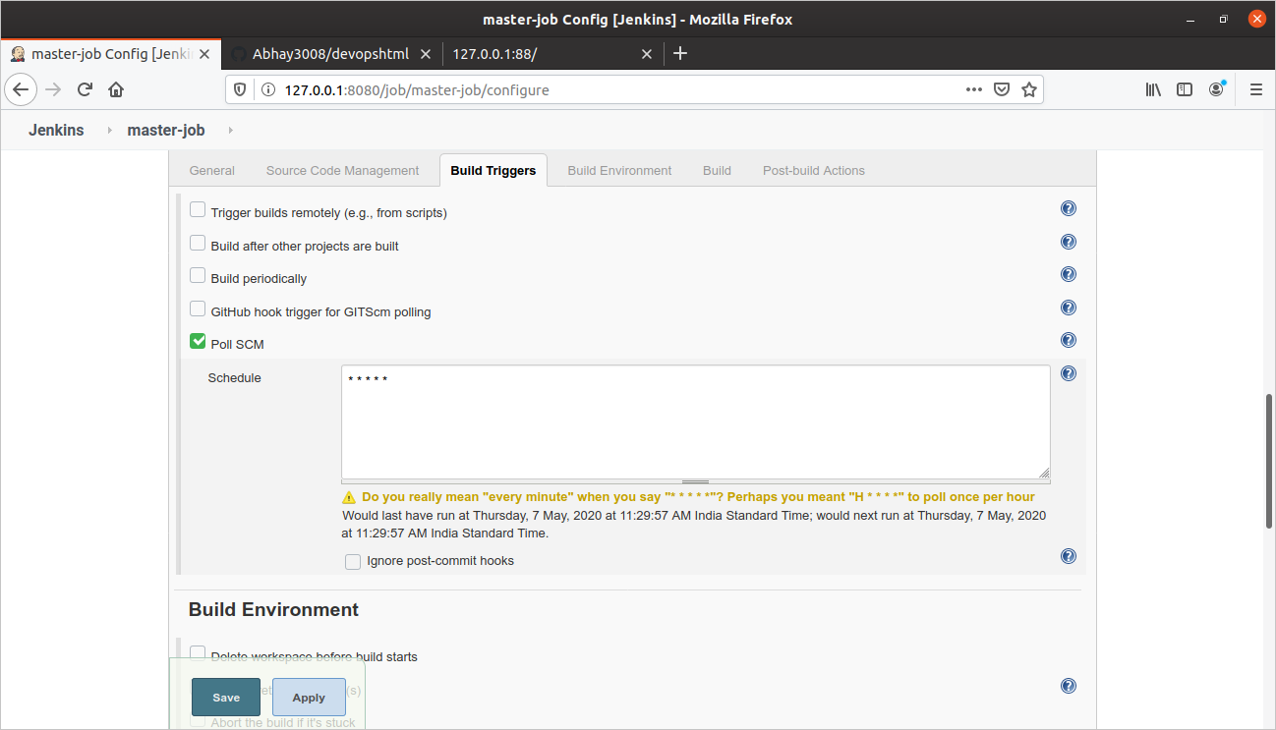

1. Write code in execute shell to run an os in docker and copy jenkins ws data with ws linked with docker image .

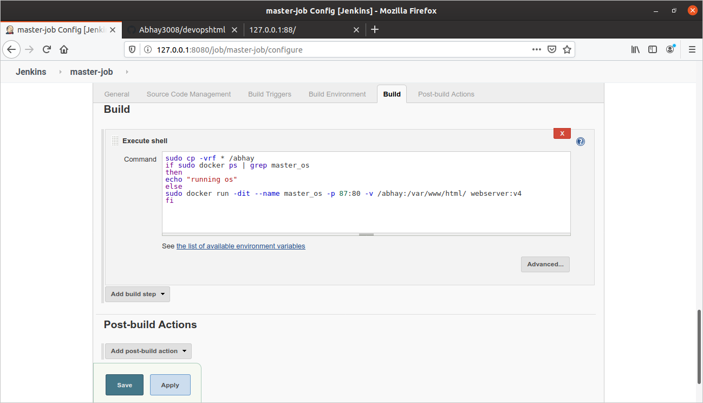

**- CREATING JOB2**

1. Create jov2 dev-job and provide git link and set dev branch for cloning.

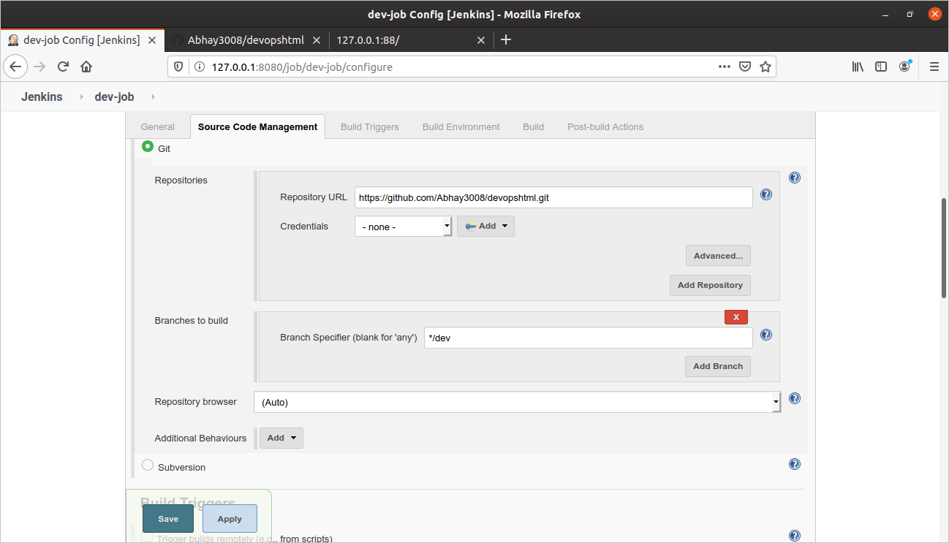

1. Set build triggers to every minute.

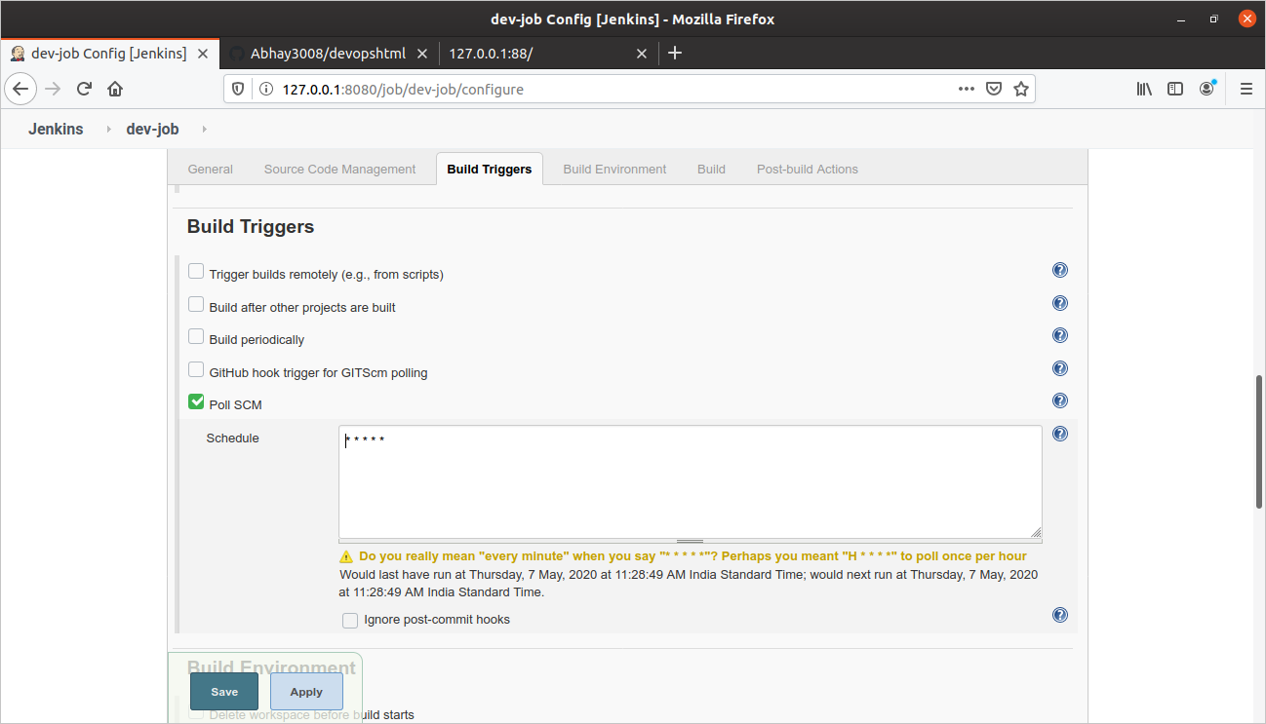

1. Write code for launching dev-os and link test ws with docker ws.

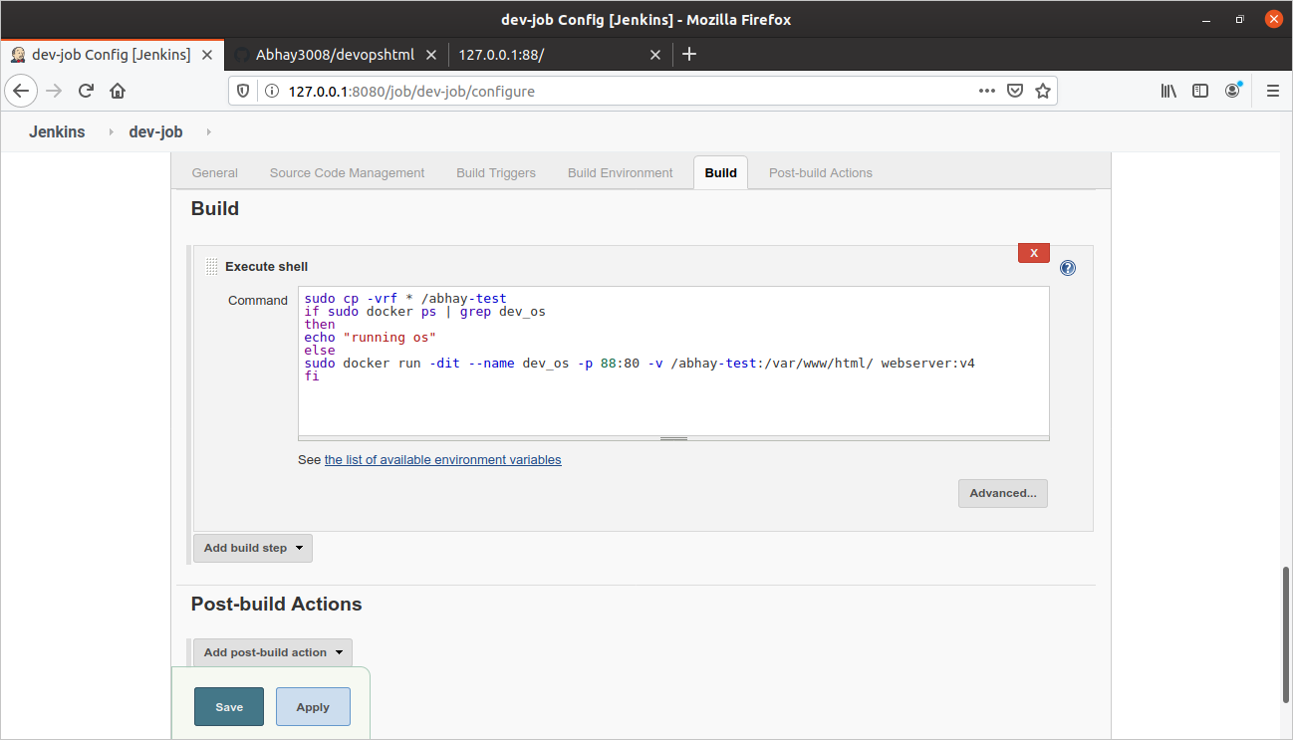

**CREATING JOB3**

1. Create job3 for testing .

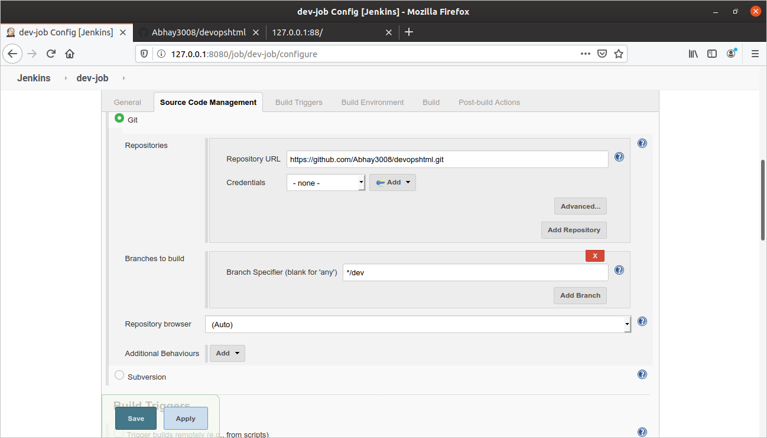

1. Edit build triggers as show in picture.

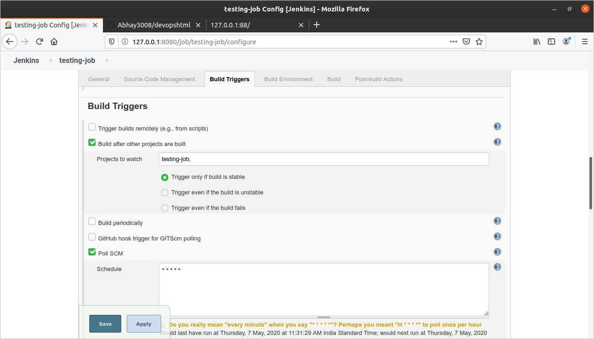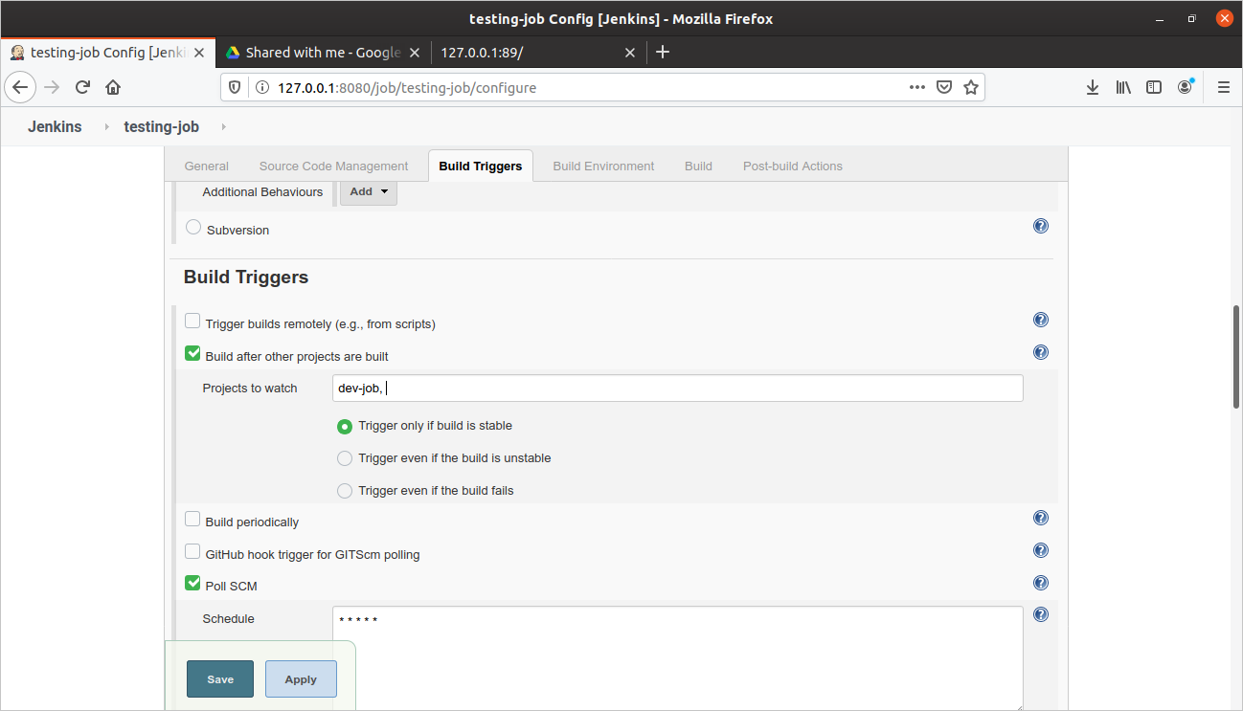

1. Edit post build action for pushing to master branch .

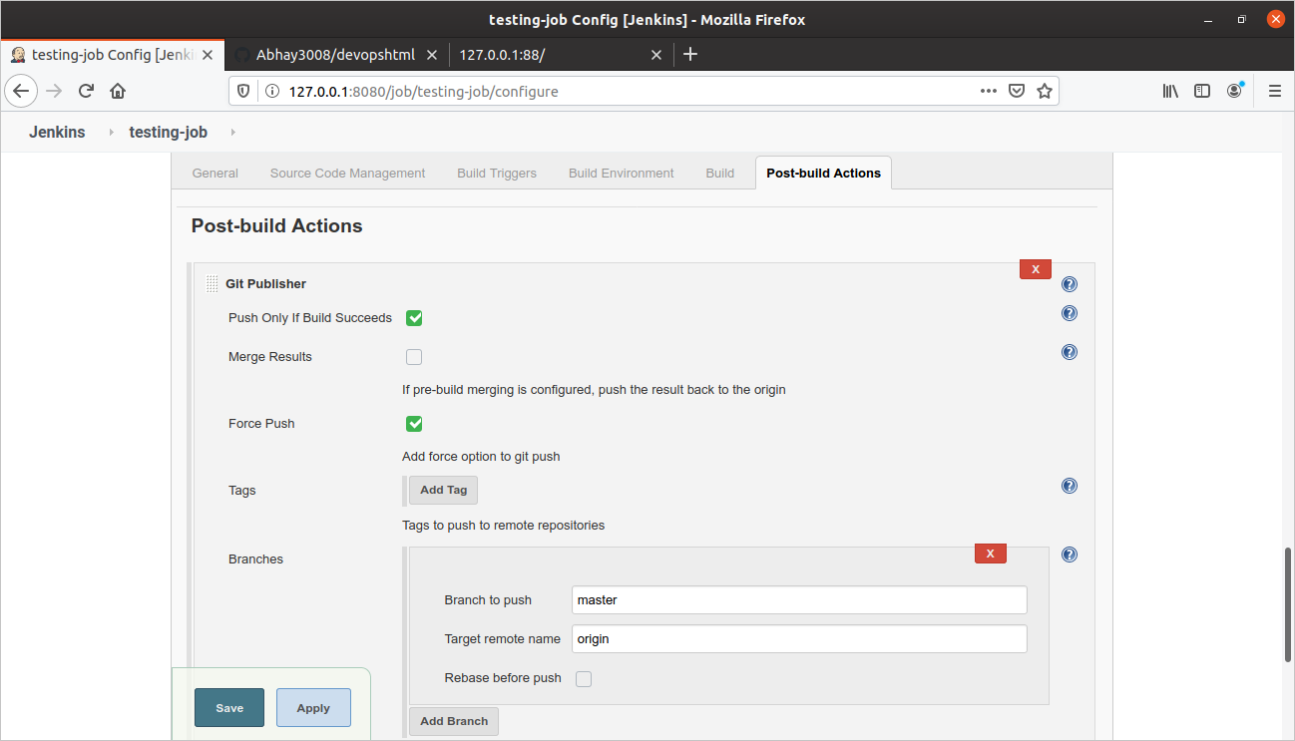

1. JOB is Done, Here is a screenshot after testing.

